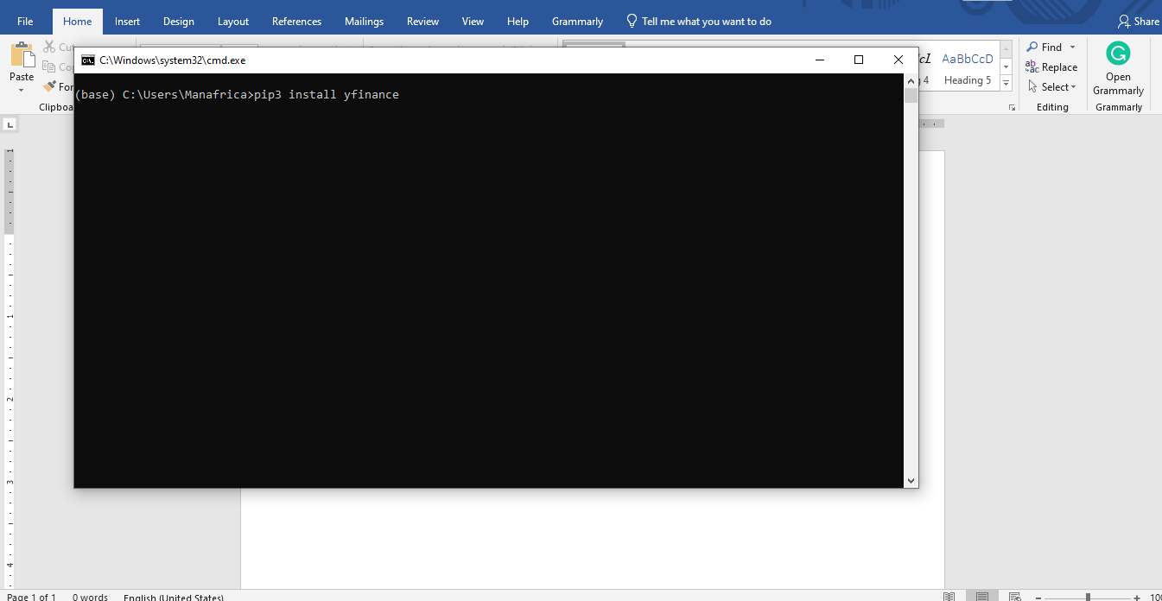
Key Points for Notes on Step 1:
- Installing yfinance:
  - You are using the command pip3 install yfinance to install the yfinance library.
  - yfinance is used for accessing financial data from Yahoo Finance.
  - This library helps download historical stock prices, financial statements, and other relevant data for backtesting trading strategies.
- Key Features of yfinance:
  - Fetches historical stock data (daily, weekly, monthly).
  - Allows downloading live market data using get_live() or get_data().
  - Supports financial indicators and dividends.
- Next Steps:
  - After installing, you can start importing yfinance in your Python environment.
  - You can use yfinance to collect data and build out your algorithmic strategies.

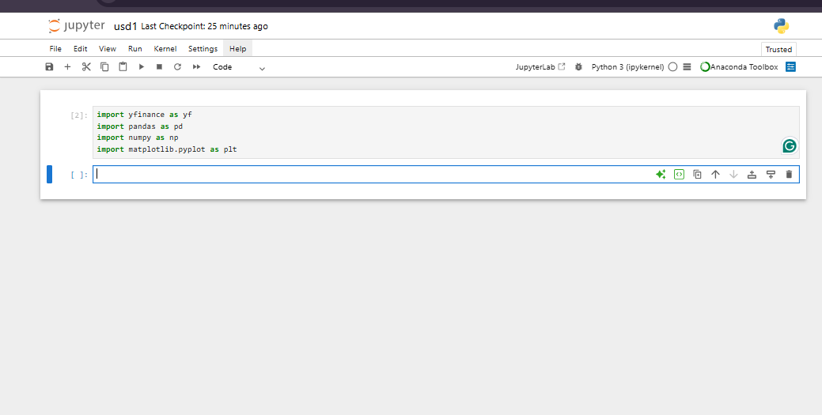
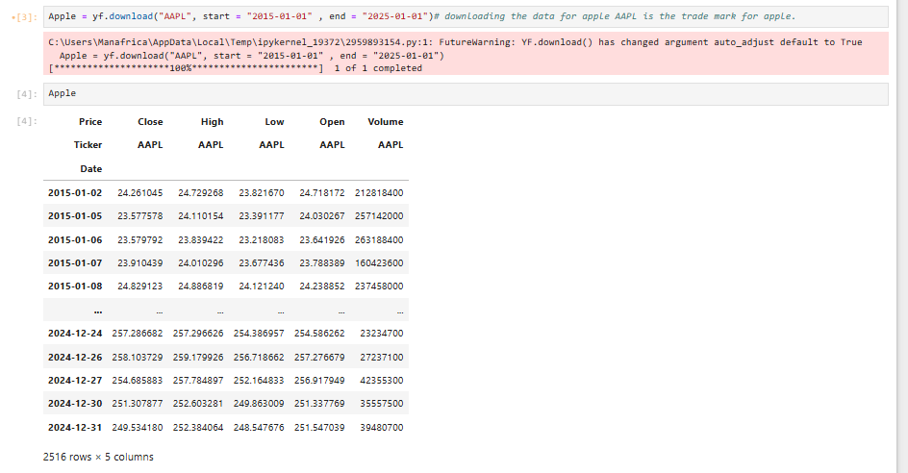

📝 Notes on Downloading Stock Data with yfinance

1. Importing Libraries
import yfinance as yf
import pandas as pd
import numpy as np
import matplotlib.pyplot as plt
- yfinance → fetches financial data like stock prices.
- pandas → used for handling data in tables (DataFrames).
- numpy → used for numerical calculations.
- matplotlib.pyplot → used for plotting graphs.

2. Downloading Stock Data
Apple = yf.download("AAPL", start="2015-01-01", end="2025-01-01")
- "AAPL" → ticker symbol for Apple Inc.
- start="2015-01-01" → beginning date for historical data.
- end="2025-01-01" → ending date for historical data.
- Data downloaded includes:
  - Open (price at market open)
  - High (highest price of the day)
  - Low (lowest price of the day)
  - Close (price at market close)
  - Adj Close (adjusted for splits/dividends)
  - Volume (number of shares traded)

3. Warning Message
FutureWarning: YF.download() has changed argument auto_adjust default to True
- This means by default, prices are now adjusted for dividends and stock splits.
- ✅ This is okay, but if you want raw prices, you can set:
Apple = yf.download("AAPL", start="2015-01-01", end="2025-01-01", auto_adjust=False)

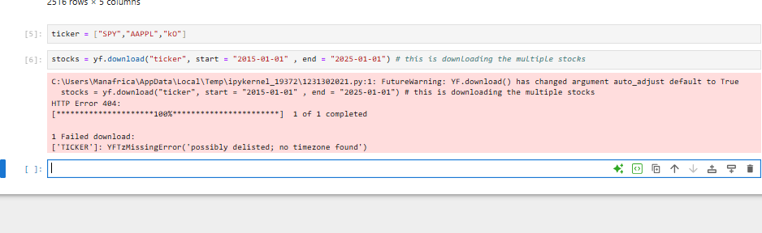
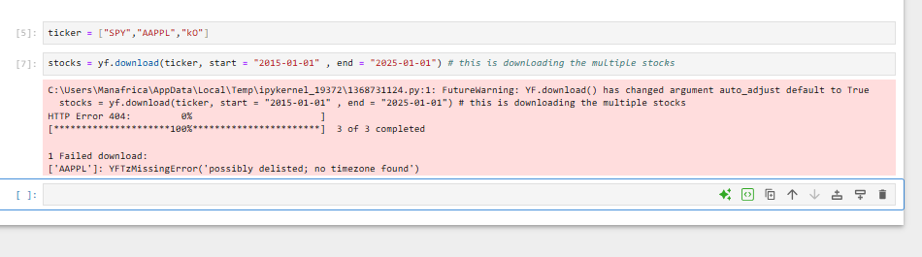
In your tickers list, you wrote:
ticker = ["SPY","AAPPL","KO"]
❌ "AAPPL" is incorrect.
✅ The correct ticker for Apple is "AAPL" (only 1 P).

Corrected Code
ticker = ["SPY", "AAPL", "KO"] # correct Apple ticker

stocks = yf.download(ticker, start="2015-01-01", end="2025-01-01")

Why you saw this error:
- yfinance tried to fetch "AAPPL" from Yahoo Finance, but that ticker does not exist → so it returned:
['AAPPL']: YFZMissingError('possibly delisted; no timezone found')
- This message means either the ticker is delisted, misspelled, or doesn’t exist at all.

✅ After fixing it to "AAPL", all 3 tickers (SPY, AAPL, KO) will download properly.
Would you like me to also show you how to plot and compare the closing prices of these 3 stocks on one chart?
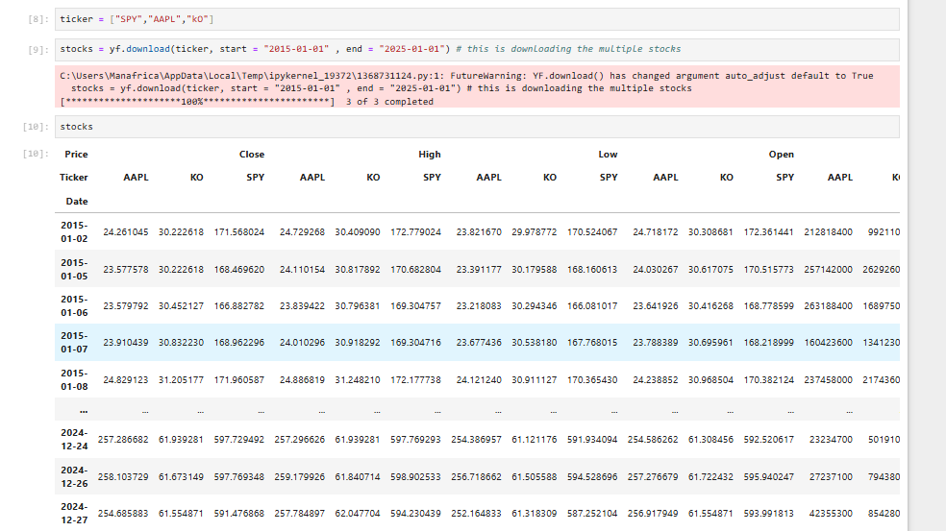

📝 Notes on Downloading Multiple Stocks with yfinance

1. Define Tickers
ticker = ["SPY", "AAPL", "KO"]
- SPY → S&P 500 ETF (tracks US stock market).
- AAPL → Apple Inc.
- KO → Coca-Cola.
- A list is used so you can download multiple tickers at once.

2. Download Data
stocks = yf.download(ticker, start="2015-01-01", end="2025-01-01")
- Downloads daily historical data for all tickers between 2015–2025.
- Returns a pandas DataFrame with a MultiIndex structure:
  - Level 1 (Price Types): Open, High, Low, Close, Adj Close, Volume.
  - Level 2 (Tickers): AAPL, KO, SPY.

3. DataFrame Layout
Your stocks DataFrame looks like this:
Date | Price | AAPL | KO | SPY
2015-01-02 | Close | 24.26 | 30.22 | 171.56
 | High | 24.79 | 30.40 | 172.77
 | Low | 23.82 | 29.97 | 170.52
 | Open | 24.72 | 30.30 | 172.36
 | Volume | ... | ... | ...
🔹 This is called a MultiIndex DataFrame → columns are organized in 2 levels (Price Type and Ticker).

4. How to Select Data
- Close price for Apple only:
stocks['Close']['AAPL']
- Close price for all tickers:
stocks['Close']
- Volume for Coca-Cola:
stocks['Volume']['KO']

5. Next Steps (Common Analysis)
- Plot closing prices:
stocks['Close'].plot(figsize=(12,6))
plt.title("Stock Closing Prices (2015–2025)")
plt.show()
- Calculate daily returns:
returns = stocks['Close'].pct_change()
- Compare performance (cumulative return):
(1 + returns).cumprod().plot(figsize=(12,6))
plt.title("Cumulative Returns (2015–2025)")
plt.show()
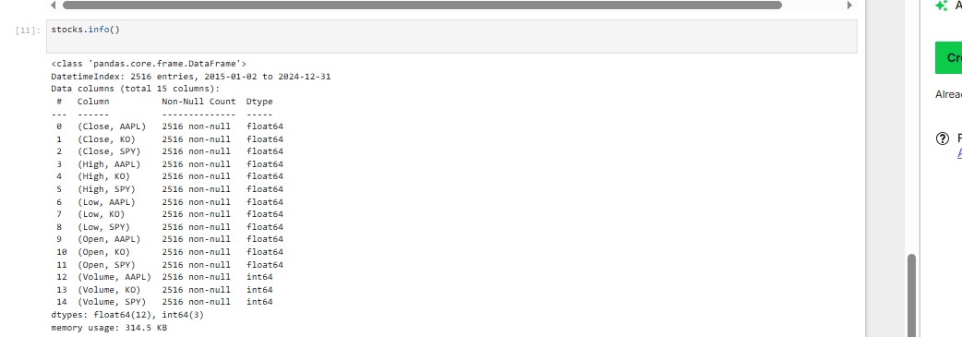

📝 Notes on stocks.info()

1. Basic DataFrame Info
<class 'pandas.core.frame.DataFrame'>
DatetimeIndex: 2516 entries, 2015-01-02 to 2024-12-31
- The index is dates (trading days).
- 2,516 rows → each row is one trading day between Jan 2015 and Dec 2024.
- This confirms weekends & holidays are excluded (since markets are closed).

2. Columns
Total columns: 15
- You have 15 columns because:
  - 5 price types (Close, High, Low, Open, Volume)
  - × 3 tickers (AAPL, KO, SPY)
  - 5 × 3 = 15

3. Data Types
- float64 → used for price data (Close, Open, High, Low).
- int64 → used for Volume.
- This is typical since volumes are whole numbers while prices can have decimals.

4. Memory Usage
memory usage: 314.5 KB
- Very small → pandas can easily handle this dataset in memory.

5. MultiIndex Flattened
Notice how columns look:
(Close, AAPL)
(Close, SPY)
(Close, KO)
...
- These are MultiIndex columns (two levels: Price Type + Ticker).
- Pandas flattens them into tuples when you call .info().

6. How to Select Data
- All Closing Prices:
stocks['Close']
- Apple Closing Prices:
stocks['Close']['AAPL']
- Coca-Cola Volume:
stocks['Volume']['KO']
- All High Prices:
stocks['High']
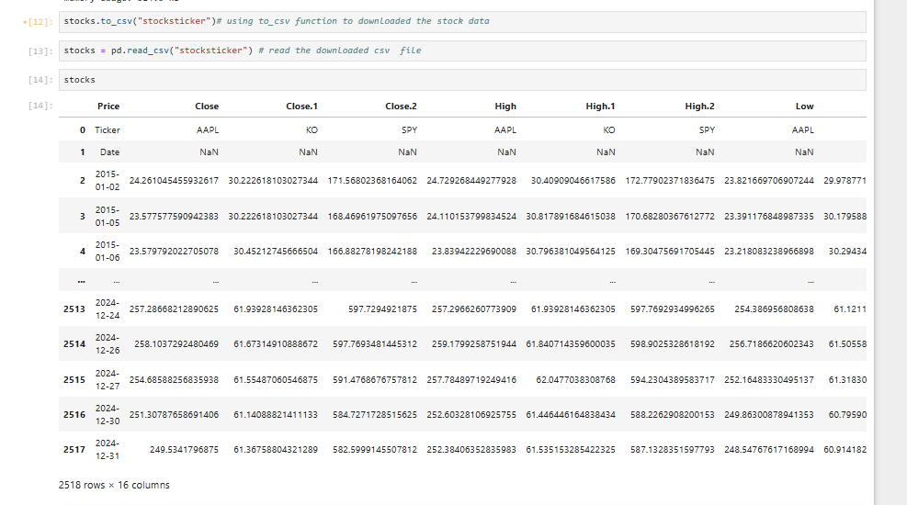

📝 Notes on Saving & Reading Stock Data (CSV)

1. Saving DataFrame to CSV
stocks.to_csv("stocksticker")
- Saves the stocks DataFrame to a CSV file named stocksticker (in your working directory).
- CSV is useful for storing and sharing data since it’s human-readable and supported by many tools (Excel, databases, etc.).
⚠️ Best practice → always add .csv at the end:
stocks.to_csv("stocksticker.csv")

2. Reading CSV Back
stocks = pd.read_csv("stocksticker")
- Reads the saved file into a new pandas DataFrame.
- Now stocks is reloaded from disk instead of memory.

3. Why Columns Look Different Now
After reloading, your columns look like:
Close Close.1 Close.2 High High.1 High.2 Low ...
This happened because:
- The original DataFrame had MultiIndex columns (e.g., (Close, AAPL)).
- When saving to CSV, pandas flattens MultiIndex into plain text headers.
- When reading back, pandas treats them as separate columns, adding .1, .2, etc. to avoid duplicates.

4. Fixing the Structure
To preserve the MultiIndex, use:
stocks.to_csv("stocksticker.csv")
stocks = pd.read_csv("stocksticker.csv", header=[0,1], index_col=0)
- header=[0,1] → tells pandas to treat the first two rows as a MultiIndex for columns.
- index_col=0 → keeps the first column (dates) as the index.
✅ This way, you’ll get the same structure back when reading the CSV as shown in the image below

5. Key Points to Remember
- .to_csv() saves DataFrames to a CSV file.
- .read_csv() loads them back, but column formatting may change.
- Use header=[0,1] when working with MultiIndex DataFrames.
- Without it, pandas flattens the structure → leading to columns like Close.1, Close.2.
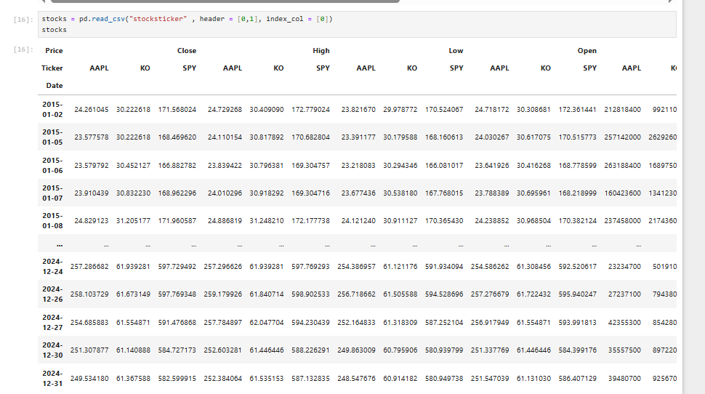

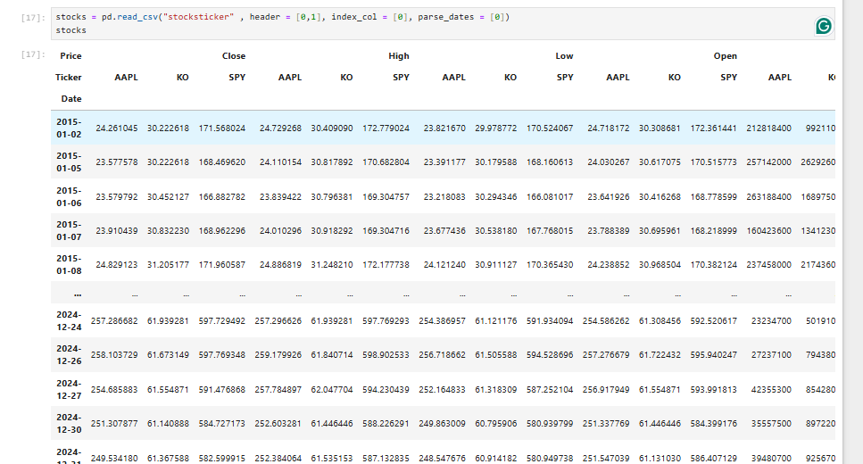

📝 Notes on Reloading MultiIndex CSV Correctly

1. The Command Used
stocks = pd.read_csv(
"stocksticker",
header=[0,1], # first two rows as multi-level column headers
index_col=[0], # first column (Date) as index
parse_dates=[0] # parse Date column into datetime format
)

2. Explanation of Parameters
- header=[0,1]
  - Tells pandas the CSV has two header rows (Price type + Ticker).
  - Restores MultiIndex columns like (Close, AAPL) instead of Close.1.
- index_col=[0]
  - Sets the first column (Date) as the index.
  - Keeps the DataFrame aligned as a time series.
- parse_dates=[0]
  - Ensures that the Date index is properly recognized as datetime, not plain strings.

3. Result
Now your DataFrame looks clean again:
- Columns are MultiIndex:
  - Level 1 → Price Type (Close, High, Low, Open, Volume).
  - Level 2 → Ticker (AAPL, KO, SPY).
- Index is a proper DatetimeIndex (2015-01-02 → 2024-12-31).
- No duplicate column names like Close.1.

4. Example Usage
- Apple Closing Prices:
stocks['Close']['AAPL'].head()
- All Closing Prices Together:
stocks['Close']
- Plot SPY vs AAPL Closing:
stocks['Close'][['AAPL','SPY']].plot(figsize=(10,6))

✅ Key Takeaway:
When saving MultiIndex DataFrames to CSV, use header=[0,1] and index_col=[0] with pd.read_csv() to restore the exact original structure.

📝 Notes on Flattened MultiIndex Columns in Stock Data
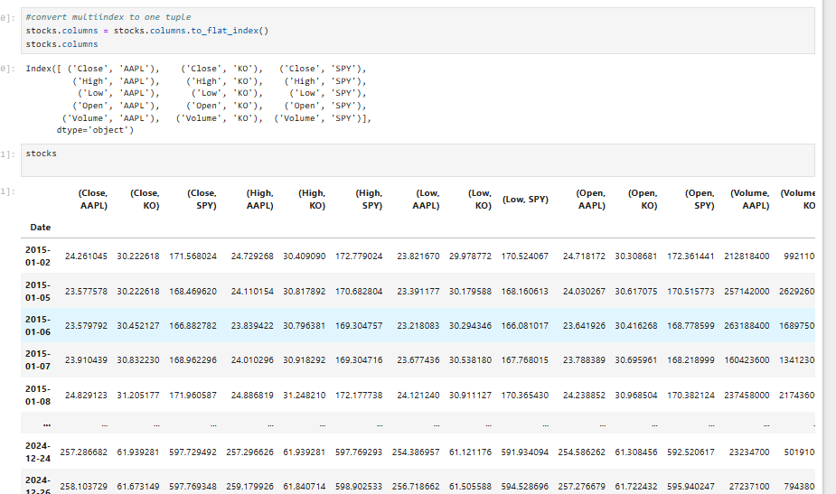
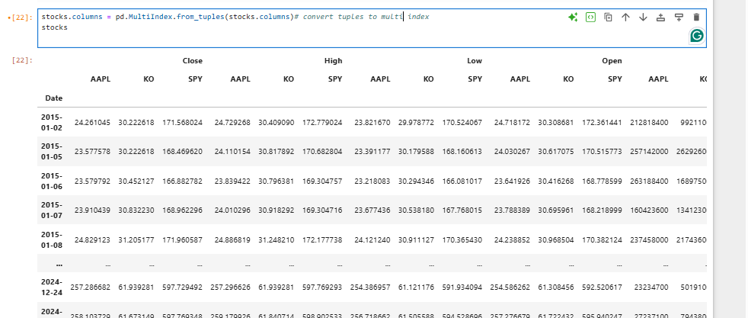

1. What Happened
stocks.columns = stocks.columns.to_flat_index()
- The original MultiIndex (('Close', 'AAPL')) is now a tuple stored in a flat Index.
- Columns look like:
('Close', 'AAPL'), ('Close', 'KO'), ('Close', 'SPY'),
('High', 'AAPL'), ('High', 'KO'), ...
So you still have the hierarchical meaning, but each column is a single tuple instead of a 2-level MultiIndex.

2. Why This Matters
- With a true MultiIndex, you could select like:
stocks['Close']['AAPL']
- After flattening, you must select with tuples:
stocks[('Close', 'AAPL')]
⚠️ This is less convenient for analysis and plotting, since tuple-based access is more verbose.

3. Making Columns Simpler (Optional)
If you prefer clean column names:
stocks.columns = ['{}_{}'.format(level1, level2) for level1, level2 in stocks.columns]
stocks.head()
✅ Output columns:
Close_AAPL Close_KO Close_SPY
High_AAPL High_KO High_SPY
Low_AAPL Low_KO Low_SPY
Open_AAPL Open_KO Open_SPY
Volume_AAPL Volume_KO Volume_SPY
Now you can select data like:
stocks['Close_AAPL']
stocks[['Close_AAPL', 'Close_SPY']]

4. When to Keep vs Flatten
- Keep MultiIndex if:
  - You want structured grouping (e.g., by Close, High, Volume).
  - You’re doing hierarchical operations (like .stack() or .groupby(level=0)).
- Flatten to strings if:
  - You want easier column access (Close_AAPL instead of ('Close','AAPL')).
  - You’re exporting to CSV, Excel, or plotting libraries that don’t handle MultiIndex well.

✅ Summary:
- .to_flat_index() gives you tuples for each column (one step flatter than MultiIndex).
- If you need clean, single-level column names, join levels into strings (Close_AAPL).
- Choose the structure based on whether you prioritize clarity or hierarchical grouping.
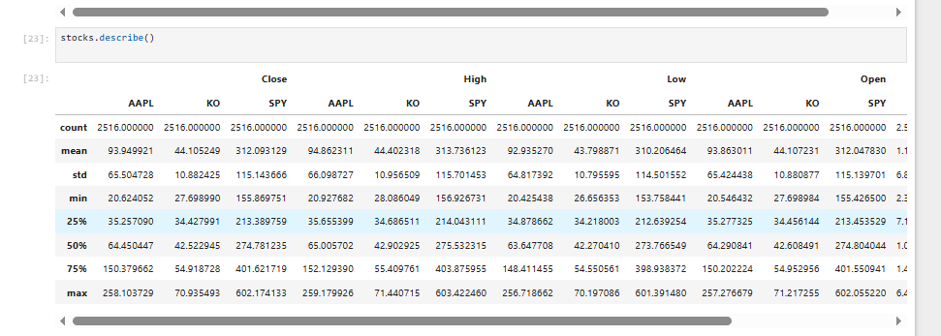

📝 Notes on .describe() for Stock Data

1. What .describe() Does
- Provides descriptive statistics for each numeric column in the DataFrame.
- Default stats: count, mean, std, min, 25%, 50%, 75%, max.
- Works separately for each ticker (AAPL, KO, SPY) and price type (Close, High, Low, Open).

2. Key Metrics Explained
For each stock price type:
- count → Number of trading days (2516 = ~10 years).
- mean → Average price over the period.
- std (standard deviation) → Volatility measure; higher = more price fluctuations.
- min / max → Lowest and highest values during the time period.
- 25%, 50%, 75% → Quartiles:
  - 25% → Price at which 25% of days are below.
  - 50% → Median price (better than mean if data is skewed).
  - 75% → Price at which 75% of days are below.

3. How to Use This in Stock Analysis
- Volatility Check:
Compare std across tickers. Example: SPY has std ≈ 115 → more volatile than KO (std ≈ 10).
- Growth Range:
Look at min vs max for each ticker. Example:
  - AAPL grew from ~$20 → ~$258 (huge growth).
  - KO grew from ~$27 → ~$71 (slower growth).
  - SPY grew from ~$156 → ~$602 (reflecting overall market growth).
- Risk vs Stability:
  - KO has lower std → more stable, defensive stock.
  - AAPL has higher std → more growth-oriented but riskier.
  - SPY reflects broad market performance.

4. Example Insights from Your Output
- AAPL → Average close ≈ 93.9, max ≈ 258.1 → strong long-term growth.
- KO → Average close ≈ 44.1, max ≈ 70.9 → steady growth, low volatility.
- SPY → Average close ≈ 312, max ≈ 602 → doubled in 10 years.

5. Next Steps (Typical in Analysis)
- Compare daily returns instead of raw prices:
returns = stocks['Close'].pct_change()
returns.describe()
- Visualize distributions:
returns.hist(bins=50, figsize=(10,6))
- Compare correlations:
returns.corr()
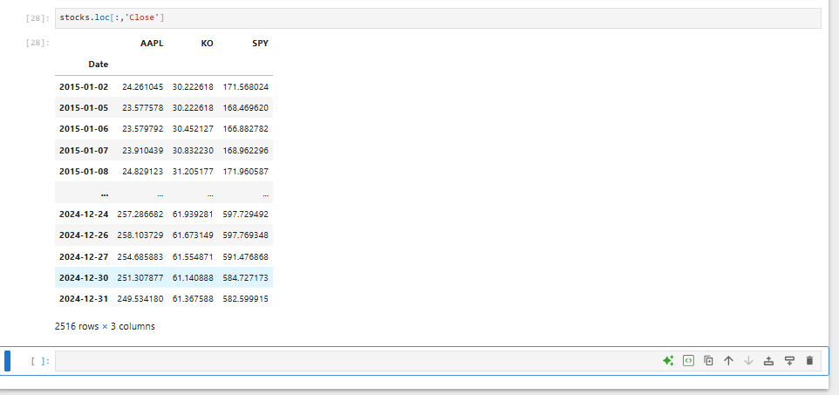
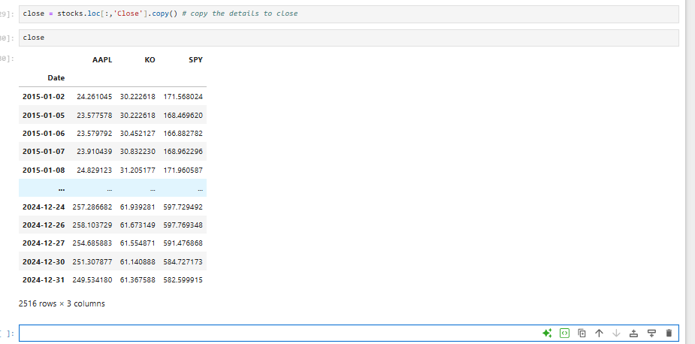

📝 Notes on Extracting Closing Prices

1. Code Used
close = stocks.loc[:, 'Close'].copy()
- stocks.loc[:, 'Close'] → Selects all rows (:) and only the 'Close' columns.
- .copy() → Creates a new independent DataFrame so changes to close don’t affect stocks.

2. Result
- New DataFrame close with closing prices only.
- Columns: AAPL, KO, SPY.
- Index: Trading dates (2015-01-02 → 2024-12-31).
- Shape: 2516 rows × 3 columns (daily closing prices for 3 tickers).

3. Why This is Useful
- Closing prices are most commonly used in:
  - Return calculations (pct_change()).
  - Moving averages (trend analysis).
  - Correlation and risk studies.
  - Portfolio backtesting.
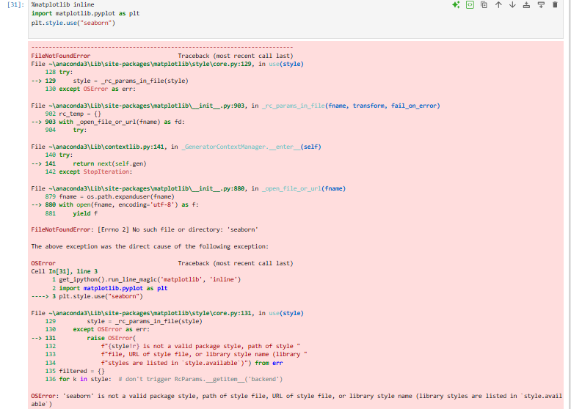

📝 Notes on Matplotlib Style Error

1. What Happened
You ran:
plt.style.use("seaborn")
and got:
OSError: 'seaborn' is not a valid package style

2. Why This Error Occurs
- Matplotlib previously included "seaborn" styles by default.
- In recent versions, they were renamed to:
  - "seaborn-v0_8"
  - "seaborn-v0_8-darkgrid"
  - "seaborn-v0_8-whitegrid"
  - "seaborn-v0_8-dark"
  - "seaborn-v0_8-white"
- Using "seaborn" now causes an error because it’s no longer recognized as a built-in style.

3. How to Fix
Option A: Use updated style names
plt.style.use("seaborn-v0_8")
Option B: Import seaborn directly
import seaborn as sns
sns.set_style("darkgrid") # or white, ticks, etc.

4. Checking Available Styles
You can see which styles your matplotlib version supports:
print(plt.style.available)

📝 Notes on Plotting Closing Prices with Matplotlib + Seaborn
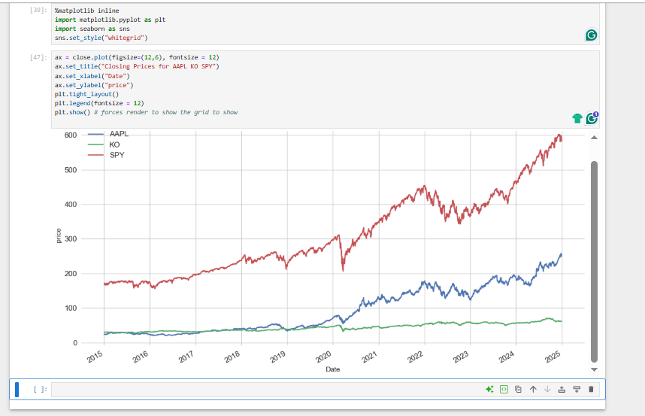

1. Setup
%matplotlib inline
import matplotlib.pyplot as plt
import seaborn as sns
sns.set_style("whitegrid")
- %matplotlib inline → Ensures plots display inside Jupyter Notebook.
- seaborn.set_style("whitegrid") → Adds a clean white background with gridlines for readability.

2. Plotting
ax = close.plot(figsize=(15,8), fontsize=12)
- close.plot(...) → Plots the closing prices for AAPL, KO, SPY.
- figsize=(15,8) → Large, clear figure.
- fontsize=12 → Sets default axis label font size.

3. Customization
ax.set_title("Closing Prices for AAPL KO SPY")
ax.set_xlabel("Date")
ax.set_ylabel("Price")
- set_title() → Adds a descriptive chart title.
- set_xlabel() / set_ylabel() → Labels axes for clarity.

4. Layout and Display
plt.tight_layout()
plt.show()

- tight_layout() → Adjusts padding so labels don’t overlap.
- plt.show() → Ensures the plot is rendered (especially important in some Jupyter environments).

plt.legend()
- Displays a box explaining what each line represents.
- Essential when plotting multiple stocks or variables.
- Makes the chart easier to interpret.

5. Result
- A clear, well-formatted time series chart showing stock closing prices for Apple (AAPL), Coca-Cola (KO), and SPY (S&P 500 ETF) from 2015–2024.
- Gridlines make trends and comparisons easy to read.

✅ Summary: You now have a professional-looking stock price chart using Pandas .plot(), styled with Seaborn’s "whitegrid", and customized with axis labels and a title. This forms the foundation for more advanced visualizations like returns, moving averages, and comparisons.

📝 Notes on Normalizing Stock Data
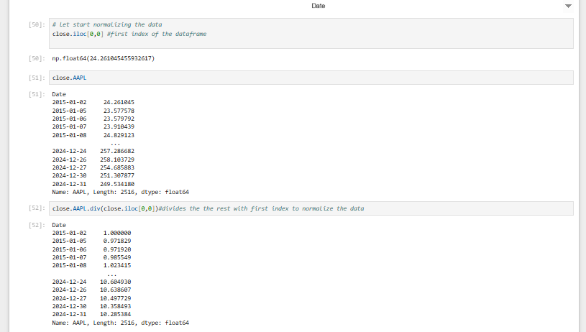

1. What You Did
close.iloc[0,0] # first value in the DataFrame
- Picks the first closing price of AAPL (on 2015-01-02 → ~24.26).
- This will be the base value for normalization.

2. Normalizing One Stock
close.AAPL.div(close.iloc[0,0])
- Divides each AAPL closing price by the first price.
- Result:
  - First value = 1.0 (baseline).
  - Later values show growth relative to start.
  - Example:
    - If normalized value = 2.0, price doubled from the start.
    - If normalized value = 0.5, price halved from the start.

3. Why Normalize?
- Stocks have very different absolute prices (AAPL ≈ 250, KO ≈ 60, SPY ≈ 600).
- Directly plotting them makes comparisons misleading.
- Normalizing puts all stocks on the same scale (starting at 1) → easy to compare growth rates.

4. Normalizing All Columns
Instead of just AAPL, normalize all tickers:
normalized = close.div(close.iloc[0])
- close.iloc[0] → gets the first row (prices on 2015-01-02).
- .div(close.iloc[0]) → divides every column by its own first value.
- Result: Each stock starts at 1.0.

5. Example Plot
normalized.plot(figsize=(12,6))
plt.title("Normalized Closing Prices (Base = 1)")
plt.ylabel("Growth (relative to first day)")
plt.show()
- Now you can compare growth trends fairly.
- If AAPL ends at 10, it grew 10× since 2015.
- If KO ends at 2, it only doubled.

✅ Summary:
You used the first closing price as a baseline to normalize stock data. This method makes it possible to compare relative growth across multiple stocks, regardless of their starting price levels.
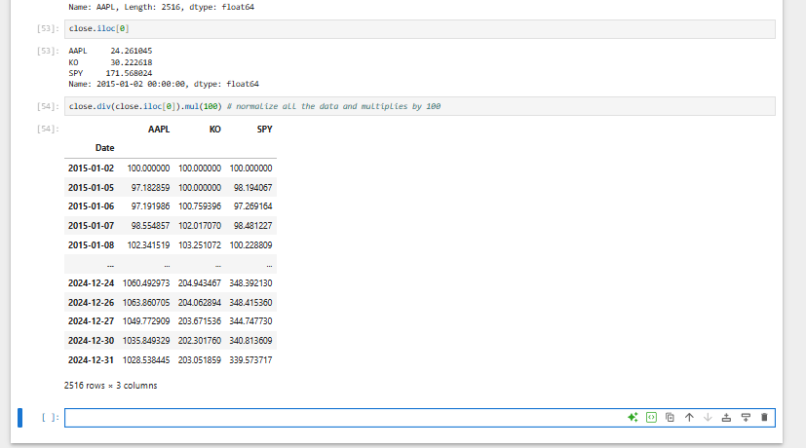

📝 Notes on Normalizing Stock Prices to Base 100

1. Code Used
close.iloc[0] # first row (starting prices for all tickers)
- Returns the first day’s closing prices (2015-01-02):
  - AAPL ≈ 24.26
  - KO ≈ 30.22
  - SPY ≈ 171.56
close.div(close.iloc[0]).mul(100)
- Divides each stock’s prices by its first value.
- Multiplies by 100 so that all stocks start at 100.

2. Why Multiply by 100?
- Previous normalization (/ close.iloc[0]) started all series at 1.0.
- Multiplying by 100 makes the starting point more intuitive (like an index).
- Example:
  - 150 → stock grew 50% since start.
  - 200 → stock doubled (100% growth).
  - 50 → stock lost half its value.

3. Result
- A new DataFrame where:
  - AAPL, KO, and SPY all start at 100 on the first day.
  - Future values represent relative performance compared to start.
- Example from your output:
  - By 2024-12-27:
    - AAPL ≈ 1049 → grew ~10.5× since 2015.
    - KO ≈ 203 → grew ~2×.
    - SPY ≈ 340 → grew ~3.4×.

4. Why This is Useful
- Allows fair comparison of growth across stocks with different price levels.
- Very common in financial research and portfolio analysis.
- Equivalent to constructing a base-100 index.

📝 Notes on Normalized Stock Price Chart (Base = 100)
- 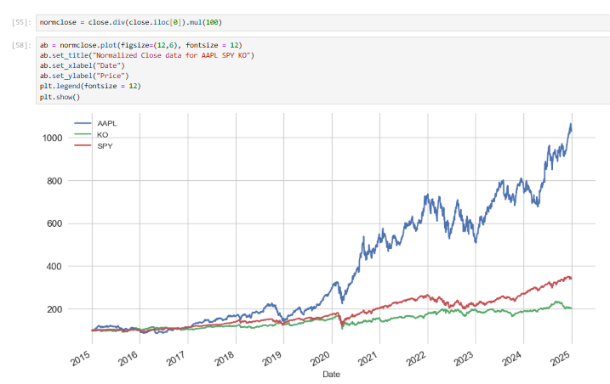

1. Code Summary
normclose = close.div(close.iloc[0]).mul(100)
- Normalized stock prices so all tickers (AAPL, KO, SPY) start at 100 on 2015-01-02.
- Makes comparisons fair regardless of original price differences.
ab = normclose.plot(figsize=(12,6), fontsize=12)
ab.set_title("Normalized Close data for AAPL SPY KO")
ab.set_xlabel("Date")
ab.set_ylabel("Price")
plt.legend(fontsize=12)
plt.show()
- Plots normalized prices with clear axis labels, title, and legend.

2. Interpretation of the Chart
- AAPL (Blue)
  - Huge growth since 2015.
  - Ends above 1000 → grew ~10× relative to its 2015 level.
  - Clear upward trend with some volatility (especially post-2020).
- KO (Green)
  - Much flatter growth.
  - Ends around 200 → ~2× growth over 10 years.
  - Stable but lower-return stock, typical for defensive/consumer staples.
- SPY (Red)
  - Represents the S&P 500 index ETF.
  - Ends around 350 → ~3.5× growth since 2015.
  - Captures overall market performance.

3. Why Normalization Helps
- Raw prices (AAPL ≈ 250, KO ≈ 60, SPY ≈ 600) are not directly comparable.
- Normalization (base 100) shows relative performance, not absolute price.
- Makes it clear that:
  - AAPL massively outperformed the market.
  - KO underperformed relative to SPY.

📝 Notes on Extracting AAPL Data into Its Own DataFrame
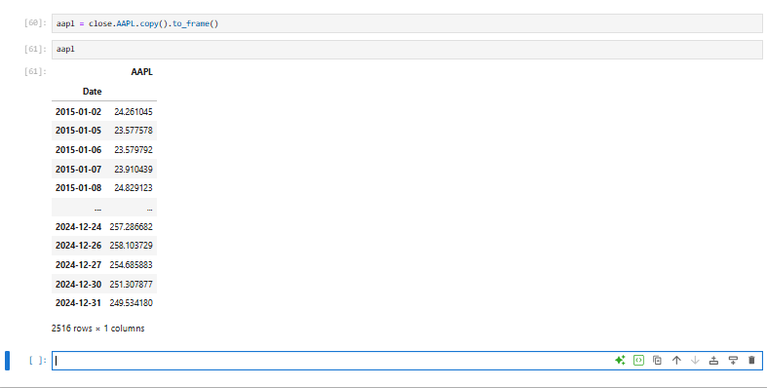

1. Code Used
aapl = close.AAPL.copy().to_frame()
- close.AAPL → selects Apple’s closing prices (a Series).
- .copy() → makes a safe copy so changes won’t affect the original close DataFrame.
- .to_frame() → converts the Series back into a DataFrame (one column).

2. Result
- aapl is a DataFrame with:
  - Index → Dates (2015-01-02 → 2024-12-31).
  - Column → AAPL (closing prices).
- Shape: 2516 rows × 1 column.

3. Why Convert to DataFrame?
- A Series (single column) is fine for simple operations.
- But converting to a DataFrame makes it:
  - Easier to merge/join with other datasets.
  - Easier to add new columns (e.g., returns, moving averages).
  - Consistent with Pandas workflows when working with multiple indicators.
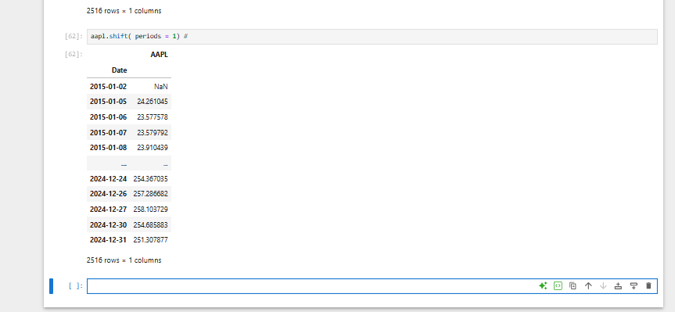
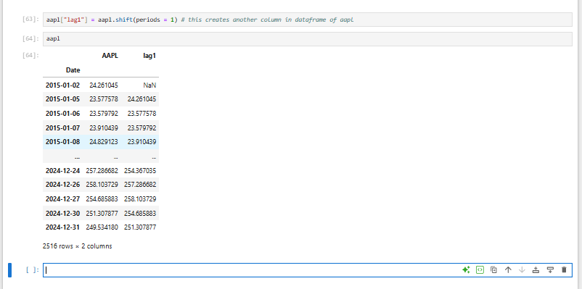

📝 Notes: shift() and creating a lag column

1) aapl.shift(periods=1)
- What it does: moves the series down by 1 row (lags it by one period).
- Why the first value is NaN: there’s no “previous day” for the first row.
- Index stays the same: only the values move; dates don’t change.
- Common use: align “yesterday’s price” with today’s date to build signals without look-ahead.

Mini example
Date | AAPL (price) | shift(1)
D1 | 100 | NaN
D2 | 102 | 100
D3 | 101 | 102

Variations
- shift(2): lag by 2 days.
- shift(-1): lead by 1 (moves values up; often unsafe for trading because it leaks future info).

2) aapl['lag1'] = aapl.shift(periods=1)
- What it does: creates a new column named lag1 inside the aapl DataFrame containing the 1-day-lagged prices.
- End result: aapl now has two columns:
  - AAPL → today’s close
  - lag1 → yesterday’s close (aligned to today’s date)
- Why this matters in trading: positions/signals computed from lag1 represent information available before today’s trade → prevents look-ahead bias.
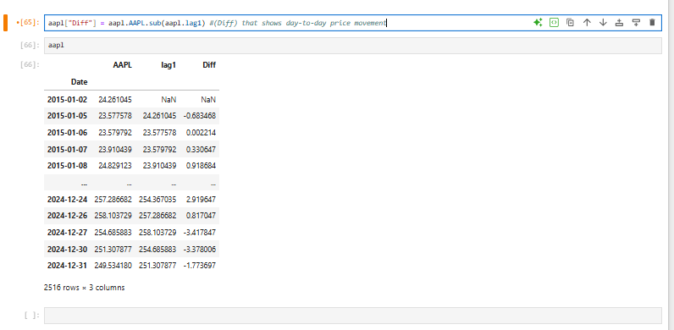

📝 Notes: Calculating Price Differences

1) The Code
aapl["Diff"] = aapl.AAPL.sub(aapl.lag1)

What happens here:
- aapl.AAPL → today’s close price.
- aapl.lag1 → yesterday’s close price (created earlier with shift(1)).
- .sub() → pandas method for subtraction (vectorized, element by element). Equivalent to:
- aapl["Diff"] = aapl["AAPL"] - aapl["lag1"]
- Result stored in a new column called Diff.

2) What Diff Means
- Diff = Today’s Price - Yesterday’s Price
- Positive → price went up compared to yesterday.
- Negative → price went down compared to yesterday.
- First row is NaN because yesterday’s price doesn’t exist (no lag for first date).

Example:
Date | AAPL | lag1 | Diff
2015-01-02 | 24.2610 | NaN | NaN
2015-01-05 | 23.5775 | 24.2610 | -0.6835
2015-01-06 | 23.5798 | 23.5775 | +0.0022
2015-01-07 | 23.9104 | 23.5798 | +0.3306

3) Why This is Useful in Trading
- Basic signal building:
If Diff > 0, the stock went up; if Diff < 0, it went down.
You can create simple strategies like:
- aapl["signal"] = (aapl["Diff"] > 0).astype(int) # 1 = up, 0 = down
- Momentum calculations:
Repeated positive Diff → uptrend.
Repeated negative Diff → downtrend.
- Volatility measurement:
Large swings in Diff → more volatile stock.
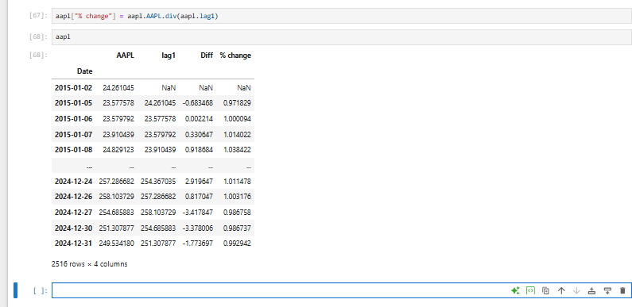

📝 Notes: Calculating % Change in Stock Prices

1) The Code
aapl["% change"] = aapl.AAPL.div(aapl.lag1)

What this does:
- aapl.AAPL → today’s price.
- aapl.lag1 → yesterday’s price.
- .div() → pandas division (element-wise). Equivalent to:
- aapl["% change"] = aapl["AAPL"] / aapl["lag1"]
So the column shows:
\text{% change} = \frac{\text{Today’s Price}}{\text{Yesterday’s Price}}

2) How to Interpret the Values
- If % change = 1.0000 → no change.
- If % change > 1 → price went up.
  - Example: 1.01 → up 1%.
- If % change < 1 → price went down.
  - Example: 0.99 → down 1%.
- First row is NaN because there is no previous day.

3) Why This is Better than Diff
- Diff shows absolute dollar change → scale depends on the stock’s price (not comparable across stocks).
- % change shows relative change → scale-free, so you can compare Apple vs. Google vs. Coca-Cola fairly.
For example:
- Apple goes from $100 → $101 (+1).
- Coke goes from $50 → $51 (+1).
- Both had +1 dollar difference, but Coke’s move is 2% gain while Apple’s is only 1% gain.
- % change highlights this distinction.

4) Improvements
- To make it look like actual % change, subtract 1:
- aapl["% change"] = aapl.AAPL.div(aapl.lag1) - 1
  - Now you’ll see 0.01 = +1%, -0.02 = -2%.
- Or use pandas’ built-in:
- aapl["% change"] = aapl["AAPL"].pct_change()

5) Common Use in Trading
- Daily Returns: % change is essentially the daily return.
- Cumulative Returns:
- aapl["cum_return"] = (1 + aapl["% change"]).cumprod()
→ shows how $1 grows if reinvested each day.
- Volatility measurement: The standard deviation of % change tells you how volatile a stock is.

✅ In short:
- Diff → raw dollar move.
- % change → normalized daily return, comparable across all assets.
- This % change column is the foundation for backtesting trading strategies (like moving averages, momentum, etc.).
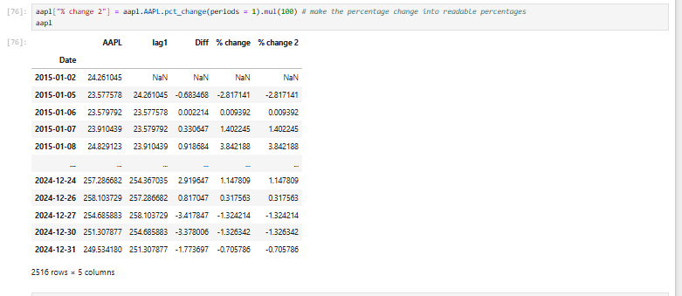

📝 Notes: Using .pct_change() and Converting to Percentages

1) The Code
aapl["% change 2"] = aapl.AAPL.pct_change(periods=1).mul(100)

What each part does:
- aapl.AAPL.pct_change(periods=1)
  - Built-in pandas method that calculates the percentage change between the current value and the previous value.
  - Formula:
\text{% change} = \frac{\text{Today’s Price} - \text{Yesterday’s Price}}{\text{Yesterday’s Price}}
- .mul(100)
  - Multiplies by 100 to turn decimals into readable percentages.
  - Example: 0.02 → 2%.
- Assignment:
- aapl["% change 2"] = ...
creates a new column % change 2 in the DataFrame.

2) Why This is Useful
- Before (% change column) → values like 0.01 = 1% gain.
- Now (% change 2 column) → values like 1.0 = 1% gain. Much clearer and standard in finance.

3) Example from Your Output
- On 2015-01-05:
  - Price dropped from 24.26 → 23.57.
  - % change 2 = -2.871741 → meaning -2.87% daily return.
- On 2024-12-24:
  - Price rose from 254.36 → 257.28.
  - % change 2 = +1.147809 → meaning +1.14% daily return.

4) Comparison Between Columns
- Diff → raw price difference.
- % change → ratio form (decimal).
- % change 2 → same ratio but expressed in percentage units (easier to read).

5) Trading & Portfolio Use
- % change 2 is what traders actually look at for daily returns.
- Can be used to:
  - Compute cumulative returns:
  - aapl["cum_return"] = (1 + aapl["% change 2"]/100).cumprod()
  - Measure risk (volatility): Standard deviation of daily % changes.
  - Build strategies: e.g., invest when average return is positive.

✅ In summary:
- .pct_change() is the most direct way to calculate returns.
- Multiplying by 100 makes it human-readable as % (finance standard).
- This column (% change 2) will now serve as the core input for any trading algorithm (momentum, mean-reversion, moving averages, etc.).
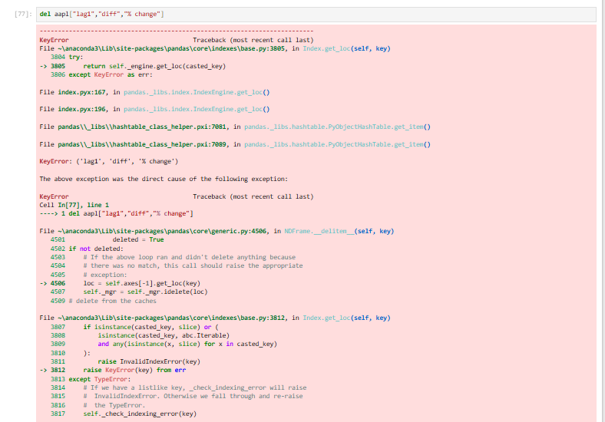
You’re getting a KeyError because the columns you’re trying to delete don’t exactly match your DataFrame’s column names.
From your earlier cells the columns are:
- "lag1" ✅
- "Diff" (capital D) ✅
- "% change" (with a space) ✅
- You also created "% change 2" later.
In the del you wrote:
del aapl["lag1","diff","% change"] # ❌ 'diff' is wrong casing; also this is a tuple key
Two issues:
- "diff" ≠ "Diff" (Pandas is case-sensitive).
- aapl["lag1","diff","% change"] is interpreted as a single tuple key, not three columns.

✅ Correct ways to drop columns

Option A — One by one
del aapl["lag1"]
del aapl["Diff"]
del aapl["% change"]
# if you also want the second one:
# del aapl["% change 2"]

Option B — In one call
aapl.drop(columns=["lag1", "Diff", "% change"], inplace=True)
# add "% change 2" if you want
# aapl.drop(columns=["lag1", "Diff", "% change", "% change 2"], inplace=True)

Option C — Be forgiving (no error if a name is missing)
aapl.drop(columns=["lag1", "Diff", "% change"], errors="ignore", inplace=True)

Quick checks
aapl.columns.tolist() # see exact names and casing

TL;DR
- Use exact column names (case + spaces matter).
- Use drop(columns=[...]) or delete one-by-one.
- Avoid aapl["col1","col2"] — that’s a tuple, not multiple columns.

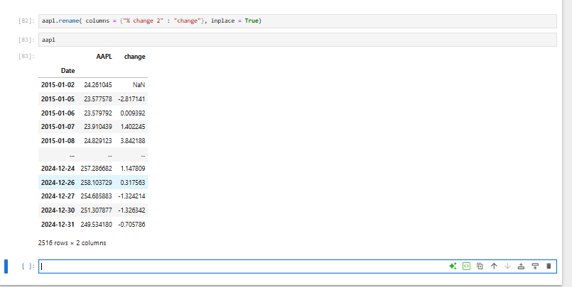

🔎 Explanation
- rename() function
  - Used in Pandas to change row indexes or column names.
  - Here, you passed the argument columns={old_name: new_name}.
  - It means: rename the column "% change 2" → "change".
- inplace=True
  - Makes the renaming permanent inside the aapl DataFrame.
  - Without it, Pandas would return a new DataFrame instead of modifying the current one.
- Result
  - Your DataFrame now has only two columns:
    - AAPL (the stock prices)
    - change (the percentage change per day)

✅ Why this is useful
- It cleans up the column names → shorter, easier to type.
- "% change 2" with spaces and symbols was awkward for code readability.
- Now you can easily reference aapl["change"] in further analysis or algorithms.

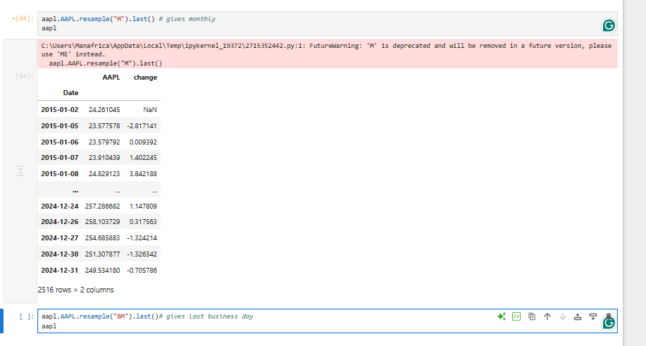
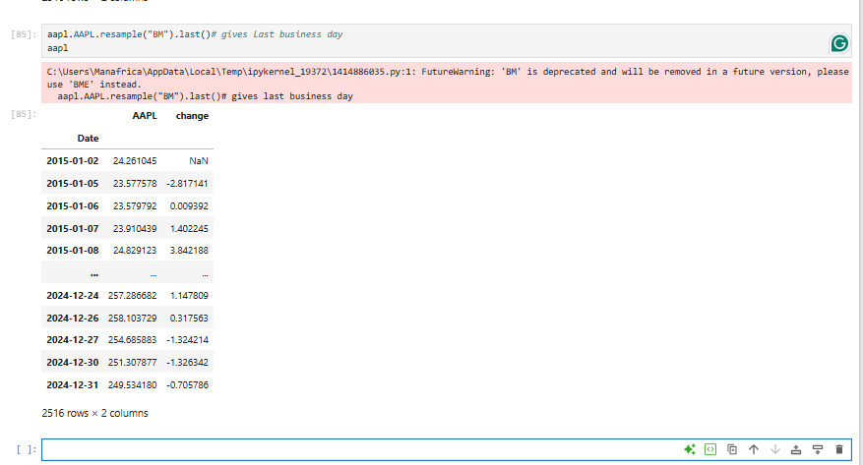

📘 Notes on resample() in Pandas (Monthly & Business Month-End Data)

1. Resampling Overview
- Resampling is used in time-series analysis to change the frequency of your data.
- It can aggregate (downsample) or interpolate (upsample) values.
- Syntax:
- df.resample(rule).agg_function()
  - rule: the new time frequency (e.g., "M", "BM", "W", "Q").
  - agg_function: what to do with values (e.g., .mean(), .sum(), .last(), .first()).

2. Monthly Resampling
aapl.AAPL.resample("M").last()
- "M" = month end (deprecated warning now suggests "ME").
- .last() = takes the last available value in each month.
- Output: Apple stock price on the last trading day of every month.
⚠️ Warning
- You saw:
- FutureWarning: 'M' is deprecated, use 'ME' instead
This means: replace "M" with "ME" going forward:
aapl.AAPL.resample("ME").last()

3. Business Month-End Resampling
aapl.AAPL.resample("BM").last()
- "BM" = business month end (last weekday of the month).
- Like "M", "BM" is also deprecated. Replace with "BME".
- aapl.AAPL.resample("BME").last()
- Why business month-end?
  - Sometimes month-end dates fall on weekends or holidays (no stock trading).
  - "BME" ensures you pick the last available trading/business day instead of an exact calendar day.

4. Key Difference
- "ME" → last calendar day of month (may fall on weekend → no stock data).
- "BME" → last business day of the month (ensures it’s a trading day).

5. What’s Happening in Your Code
- aapl.AAPL.resample("M").last()
→ Returns last stock price at month-end (deprecated, replace with "ME").
- aapl.AAPL.resample("BM").last()
→ Returns last stock price at business month-end (deprecated, replace with "BME").
